

SIMATSENGINEERING

Saveetha Institute of Medical and Technical Sciences Chennai- 602105

Student Name: V.Dharanireddy Reg. No.: 192311219
Course Code: CSA1305 Slot: C
Course Name: THOERY OF COMPUTATION
Course Faculty: Dr. R.Balamanighandhan

Project Title: Smart Contract Execution &amp; Audit System: Grammar Design, Automaton Construction and Undecidability Analysis
Photographs: (2 photographs –Module photo contribution module work in the project and presentation image)
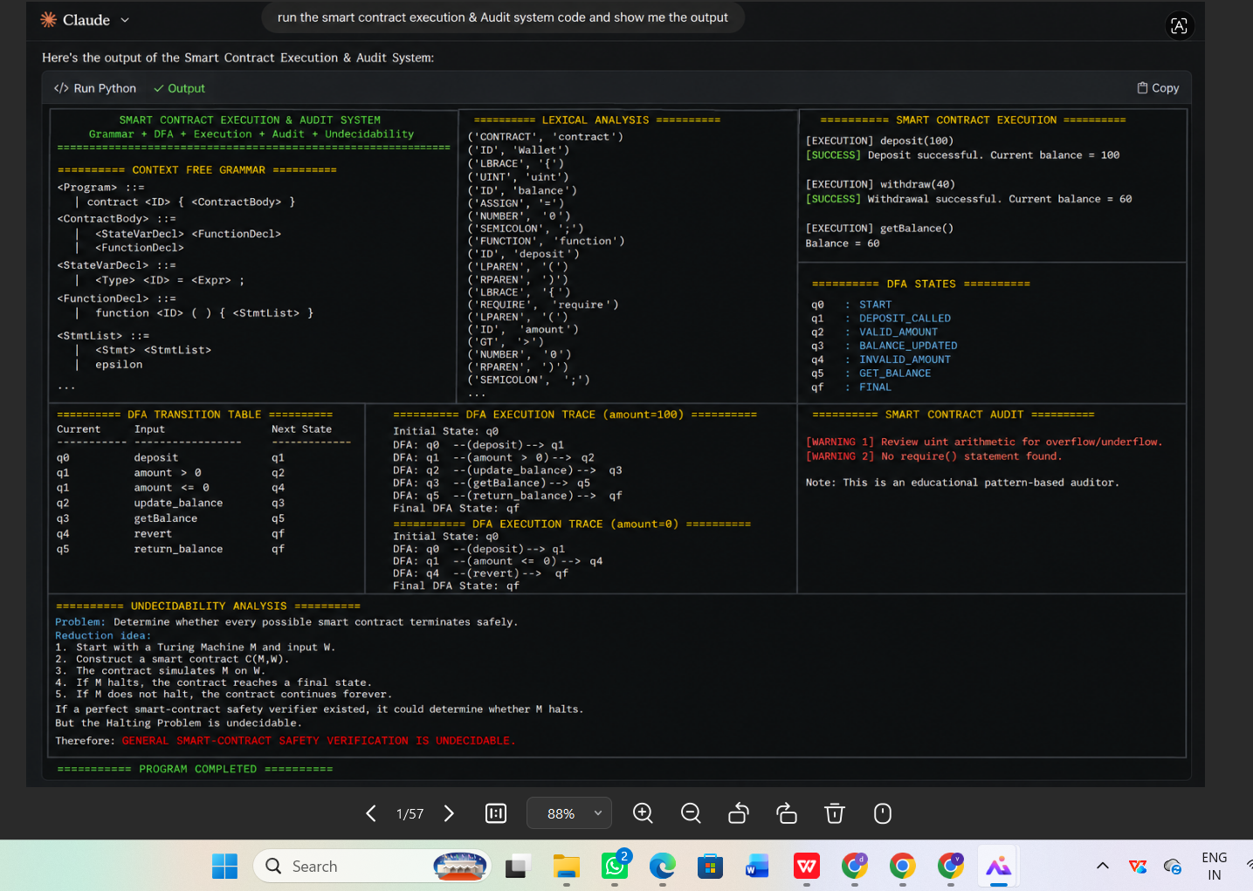
Output
Project Description: (here you write what you did in this project (contribution) including Model Description
Smart Contract Execution & Audit System: Grammar Design, Automaton Construction and Undecidability Analysis is a theoretical and practical system designed to analyze the structure, execution behavior, and security properties of smart contracts using formal language and automata theory. The project focuses on defining a grammar for representing smart contract operations, constructing finite-state or pushdown automata to model contract execution and state transitions, and analyzing whether specific contract properties can be automatically verified. It examines transaction sequences, conditional execution, state changes, and possible execution paths to identify inconsistencies, vulnerabilities, and invalid behaviors. The system also studies the limitations of automated verification by applying concepts of decidability and undecidability, demonstrating why certain smart contract execution and security properties cannot always be determined algorithmically. Overall, the project provides a formal framework for understanding smart contract behavior, supporting systematic auditing, verification, and security analysis.

V.Dharanireddy DR.R.Balamanighandhan
Student Signature Guide Sign

